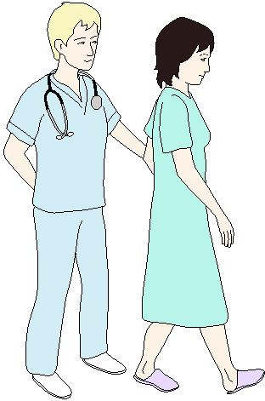
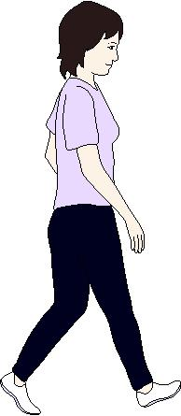

Patient Guidebook for

Enhanced Recovery after Surgery (ERAS)

Colon and Rectal Surgery

Date of Surgery:

Diagnosis:

Type of Surgery:

Name:

NRIC:

Content | Page
Introduction | 3
What you need to know about your colon and rectal surgery?  - Understand your surgery | 4
Prepare yourself before surgery  - Stop smoking  - Eat well and eat right  - Stay active | 5
2 Day before surgery and on admission  - What you need to do? | 6
Day of surgery  - What you need to do | 7
How you can improve your recovery after surgery  - Resume diet early  - Resume activities early  - Reducing pain  - Stoma care  - Discharge from the hospital | 8-10
After you go home  - What you can eat  - How to manage pain at home  - Activity and movement | 11
Questions, problems and complications | 12
Instruction on bowel preparation | 13

INTRODUCTION

Colorectal surgery is a major surgery that is made very much safer with the care, diligence and professionalism of your medical team. However, the best outcomes only occur with your understanding and your participation in your own treatment.

This guidebook will help you understand and prepare you for your surgery. your doctors and nurses will go through the contents with you, explaining how you can play a part in your recovery and what you can expect during your hospital stay. We hope to make you better prepared, both physically and mentally, for the journey ahead.

- Are checkboxes indicating important points applicable to your surgery.

IMPORTANT

- Please bring this booklet with you on your appointments with any of the following departments:

- SFUC Department of surgery
- PAC clinic (S2)
- Dietitian
- Physiotherapist (with pre-purchased spirometry)
- Stoma nurse (SFUC)
- On the day of admission

WHAT YOU NEED TO KNOW ABOUT COLON AND RECTAL SURGERY

Understand your surgery

Your surgery would involve the removal of the diseased colon and/or rectum. The surgery will be performed through either:

- Open surgery, or
- Keyhole or laparoscopy surgery.
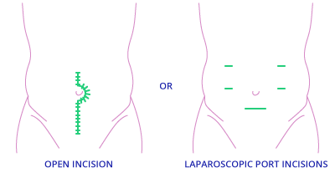

Open surgery Keyhole surgery

- Your doctors may have advised you the need to carry a stoma bag for stools after surgery. Your stoma may be permanent or temporary. You will also meet with the stoma specialist to discuss how to take care of the stoma after your surgery.
Do clarify with your doctors or nurses if you have any doubts.
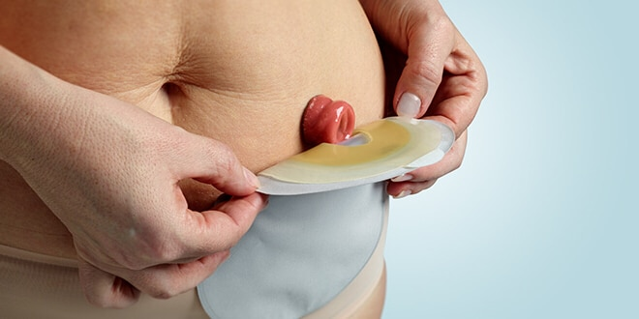

PREPARE YOURSELF BEFORE SURGERY

Stop smoking and alcohol

Smoking and alcohol consumption can potentiate complications after your surgery.

- Stop smoking and alcohol intake at least 2-4 weeks prior to surgery.
Eat well and eat right

Your body needs nutrients and energy to recover from surgery. You must continue to eat well before the surgery.

- Your doctor may also prescribe oral nutrition supplement (ONS) to take 1-2 weeks before the surgery.
- Stop all traditional medicines/supplement.
Stay active

If you are already exercising, continue to do so.
If you are not, start slowly adding exercise into your day.

- Simple exercise like a 15-30 minute walk is far better than not exercising at all. By staying active, you are likely to return to normal activities faster after the surgery.
- Practising incentive spirometry at home as taught by physiotherapist.
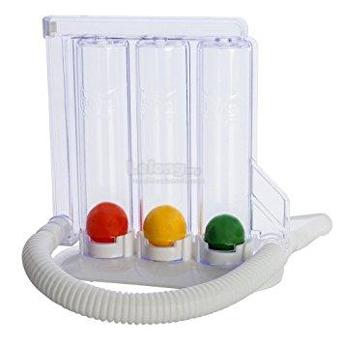

A DAY BEFORE ADMISSION

- You will receive a call from SFUC staff to confirm the date and commitment of surgery.
- Get ready packets of sugarless chewing gum for post-op use.
- You will be reminded of doing your bowel preparation using 2 sachets of Fortrans (refer to page 13 for instruction for bowel preparation).

DAY OF ADMISSION

- You will be reminded to admit to respective ward in the morning.
- You are still allowed to take low residual diet till 6 hours before surgery.
- Continue taking clear fluid (with or without sugar) till 2-3 hours before surgery.
- Glucose drink will be provided before midnight and 2-3 hours before surgery.
- The doctors will confirm with you what time you have to totally fasting.

DAY OF SURGERY

- Wear your anti-embolism (TED) stockings in the morning after shower.
- You are given options for ON-Q pre-peritoneal pain buster system, Regional block/Patient Control Analgesia (PCA) or epidural anaesthetic for pain relief during and after the surgery.
- You will then be put under general anaesthesia, and will not feel or remember anything during the surgery.
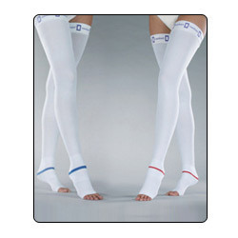

AFTER THE SURGERY

After the surgery, you will wake up in the recovery bay and then transferred to the ward. You will have a drip and may have a urinary catheter on you.

- You will be encouraged to be out of bed and sitting up for a total of 2 hours after the operation.
- You may drink a few hours after the surgery. You’re advised to take ONS up to 300cc.

HOW CAN YOU IMPROVE YOUR RECOVERY AFTER SURGERY

Resume diet early

- You may increase your oral intake, starting from drinking more fluids and nutritional drinks, to progressing to eating normal food.
- Chew your chewing gum as frequent and as much as you like.
This begins as early as on the day after surgery in order to meet your increased need for nutrition. If you encounter any nausea or vomiting or abdominal discomfort, inform the nurse or doctor.

Resume activities early

- You are expected to be out of bed, sitting at least 2 hours a day on the day after your surgery and sitting/ walking at least 6 hours a day for next few days after. Your nurse or physiotherapist will be there to assist you.
- You are also required to use your spirometer 5 times every hour whenever awake, to prevent lung infection.
Eating and engaging in physical activity after surgery help to enhance your recovery and reduce the risk of complications after your surgery. if needed, you may also get advice from a dietitian about food and nutritional drinks (ONS) before you leave the hospital.
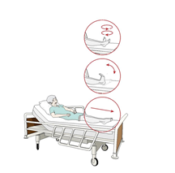

Reducing pain
Pain relief is very important for a speedy recovery to your normal activities. You should be able to move around the ward and eat without pain.

Whichever pain relief system that you chose, whether epidural anaesthesia, On-Q pain buster system or Regional Block/Patient Control Analgesia (PCA), you will continue to receive pain relief of your choice as well as oral medication, paracetamol (Panadol) for the first few days. Once the system has been removed, stronger oral pain medication will be added.
Inform any nurse or doctor immediately if any equipment malfunctions or the medicine is used up.
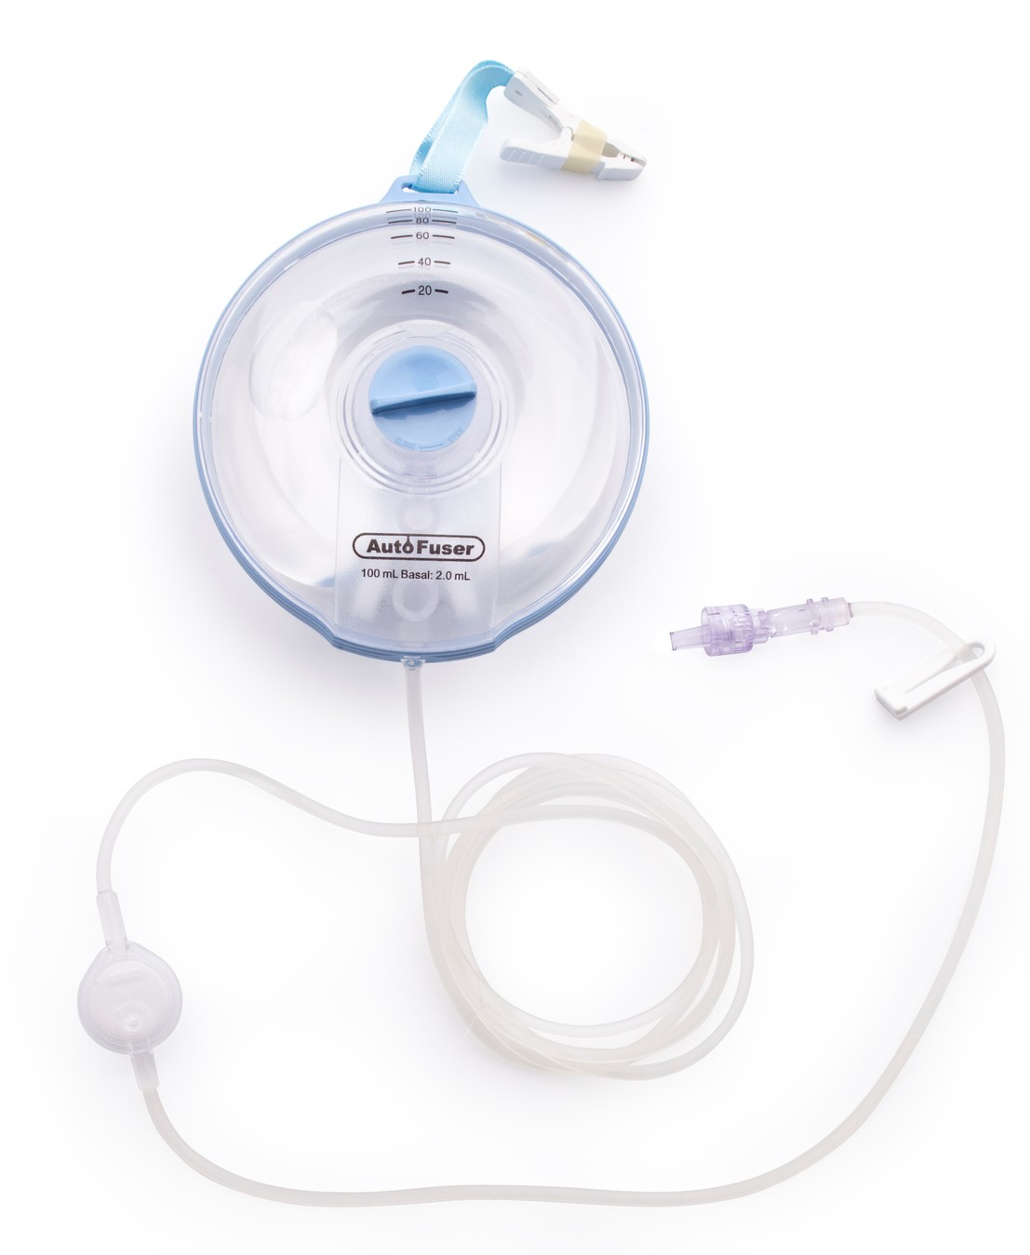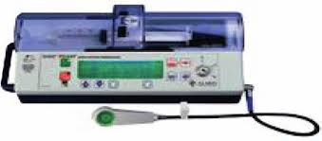
- Your doctor and nurse will ask you about your pain score. You should not feel pain more the score of 4 out of 10.
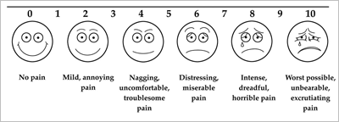

If you still experience pain despite these steps, please speak with your nurse so you can get the help that you need.

Stoma care

- If you have a stoma after the surgery, our stoma nurse will teach you and your caretaker how to manage your stoma.
You should feel confident of handling your stoma before going home.

Discharge from the hospital

- Once you have passed flatus and/or stools, and when you have satisfactory pain control using oral pain medication, you will be discharged from the hospital. Most patients can be discharged 2-5 days after surgery.
- A follow-up appointment will be scheduled with your doctor.
- A date for stitch removal will also be given to you if necessary.
- You may also option to remove On-Q catheter yourself at home if you discharge before day 4, the doctor will show you how to remove it. It’s real easy.

AFTER YOU GO HOME

What you can eat

- You can start with easily digestible (avoid vegetables and fruits) and less oily food for 2 weeks. Porridge/rice with high protein diet eg. fish, egg white etc. are encouraged and gradually progress to normal foods after 2 weeks.
It is normal to have reduced appetite for a period after surgery, but this should slowly improve.

- You may also experience more frequent stools, but this should improve over time.

How to manage pain at home

You might still experience some pain when you are at home. You will probably need to take oral pain medication to help you with your pain.

- You should just take oral Panadol regularly for a few more days after discharge and reserve the stronger pain medication for times when you really need it.

Activities and movement

- You should continue to stay active at home by taking walks, for example. You will feel increased fatigue from exercise, which could last a several weeks after the operation.
- Avoid heavy load lifting (more than half of your body weight) for about 6 weeks after your surgery.

QUESTIONS, PROBLEMS AND COMPLICATIONS

- You will receive a telephone call from your doctor (ward or SFUC) to check on your wellbeing 2-3 days after discharge.
If you feel unwell, have a fever, worsening abdominal pain, bloatedness or vomiting, inform the nurse.

If you have any questions, please contact us at the following numbers:

Colorectal Service Nurse Coordinator:
Puan Hidaryati
019-7348667

SFUC General Line:
07-2257000 Ext 2371

Ward W4
07-2257000 Ext 2409/2774

Ward E2
07-2257000 Ext 2111/2110

Ward OW
07-2257000 Ext 3530

- If you are unable to reach us at these numbers, please come to Emergency Department for immediate attention.

INSTRUCTION ON BOWEL PREPARATION

Breakfast and lunch | Low residual diet (low in fibre) like white bread with jam, plain porridge, noodles, jelly, half or hard boiled eggs (NOT FRIED).  E.g. plain tea or coffee with or without sugar (without milk), filtered fruit juice, isotonic drinks (non-carbonated).  Patients are NOT allowed to eat or drink:  Milk products, oat, Milo, vegetables, fruits and meat.
6.00pm | 1 sachet of FORTRANS + 1 litre of plain water (1000cc)  Take a cup (250cc) every 15 minutes  Continue to drink (except diary product) during bowel preparation.
6.00am | 1 sachet of FORTRANS + 1 litre of plain water (1000cc)  Take a cup (250cc) every 15 minutes  Continue to drink (except diary product) during bowel preparation.

